Name: Maryam Azhar Sap: 43755

Computer Networks

LAB 4

**Task 1:** Connect 4 PCs with the HUB in cisco packet tracer and send data from PC 1 to PC 2 and check the working of HUB through simulation mode. (05 Marks)

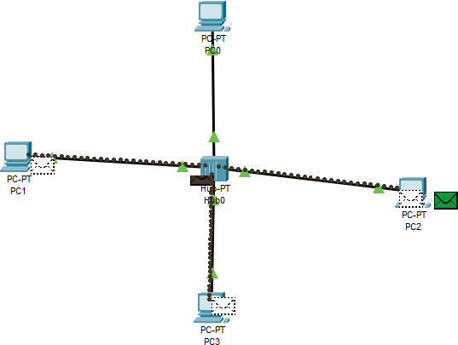

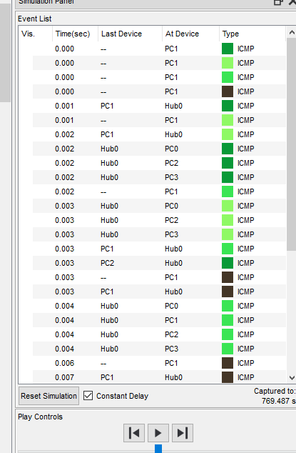

**Task 2:** Connect 4 PCs with the SWITCH in cisco packet tracer and send data from PC 1 to PC 2 and check the working of SWITCH through simulation mode. (05 Marks)

